**SYCOMORE**

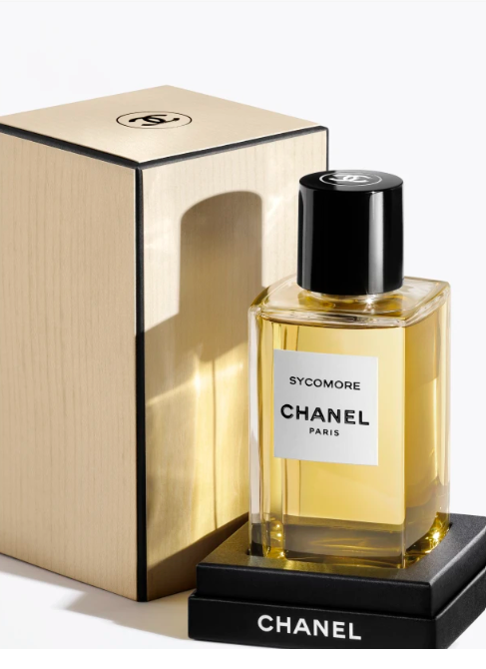

**$500**

**Product**

Created in 1930 and inspired by the noble spirit of autumn and the childhood of Gabrielle Chanel, the intensely woody scent of SYCOMORE evokes the great outdoors.

**Composition**

This pure, majestic fragrance is composed around the smoky scent of vetiver, with notes of cedar and vanilla.

**Art of perfuming**

The Eau de Parfum comes in a spray for easy application.